Inverter Test under Full load

1. **Rated Parameters of motor**

Power : 5300W

Voltage : 24V

Efficiency : 88.7%

Power factor : 0.76

Total power consumed on stator : 7862VA

Power per phase : 2620VA

Current per phase : 109A ( ~ 100A )

**Motor windings to be used as RL load for per phase testing.**

Line-line stator winding resistance : 0.2Ω (measured with multimeter)

Using magnetizing inductance for L : 0.38mH



Schematic

Connections to be made on inverter:

1. DC +- from power supply will follow the DC +- bridge marked on the inverter.
2. For the RL (motor cables), connect one to the output point of the leg (under test). Second cable of the motor will be common on the DC- bus bar.   
   Be careful that there is visible clearance between DC+ & - after the 3 heavy wires are connected (DC +- and 1 motor cable)
3. For the signal side, 4 pin connector is attached with the inverter on test bench. Enable is 3.3V, then PWM signal from signal generator (10kHz, 5V, duty min 20%) 24V for the MOSFET driver power supply. All these 3 signal/supply will share the same ground.
4. Connect the heatsink fan to 12V and place it underneath the inverter (as shown on previous report page 77).

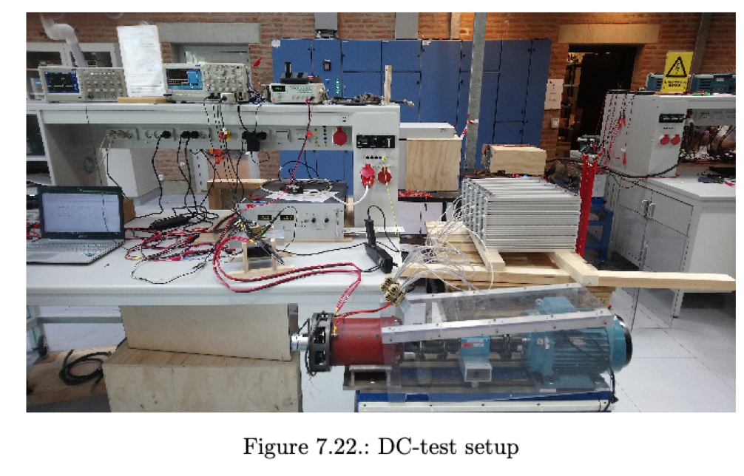

1. Make sure that the cables are not straining the busbars because they are very heavy, and we can easily snap off the busbars on inverter. As they are only held down by plastic screws.
2. Differential voltage probe on the low side MOSFET drain-source (as in schematic) (attenuation on probe matched with oscilloscope channel). After Case 2 below you can remove this as you don’t need to monitor the DS voltage.
3. Current probe on the motor wire. Make sure the flow of current and arrow indicated on probe is same (set up the attenuation accordingly on oscilloscope).
4. Place the thermal camera on top of the acrylic cover to continuously monitor the temperature.
5. Emissivity setting on camera set to Matt.

Powering on sequence:

Case 1:

1. As mentioned during light load test, always turn on the signal and mosfet gate driver power supply. Keep the duty cycle at minimum (20%). Turn on the cooling fan.
2. Set DC link voltage first to 5V and set up current limit to 10A. (For the set up the load current should not be more than 5A). Confirm that the current and voltage is as expected or close.

Case 2:

1. Now increase the DC voltage to 15V. The current should also be around 15A (hence you need to increase the current limit to atleast 50A (so you don’t have to stop test for case 3)).
2. Check if the MOSFETs are heating.

Case 3:

1. Gradually you can increase the DC link voltage to 36V. The current at 20% duty cycle (same from case 1) should also be around 36A.

Case 4:

1. From now on you have to increase duty cycle very slowly as the current reaches up to 90 A at 50% duty cycle. The MOSFET temperature as seen from the thermal camera should not exceed beyond 45℃ (as seen from the previous report).

(The above 4 cases to be conducted for the 3 legs)

NOTE : Shut down the DC link power supply first whenever anything goes wrong or turning off sequence. Never turn off the gate driver power supply first.